AMRITA VISHWA VIDYAPEETHAM, BENGALURU

Research Volunteering Work Completion Report
Name : Parth Pathak
Roll Number : BL.EN.U4CSE23036
Hours of work completed : 8 hrs

Notes:
- The students shall work for a project related to Machine learning
- The students shall understand the problem statement and ideas / thought process for solution development
- Students shall submit a report of the work done duly signed by the guide / supervisor
- No of hours spent for the volunteering work should be clearly mentioned as that would be the criteria for awarding marks
- Each 1.5 hours of work translates to 1 mark subject to a cap of 5 marks
- Max marks allocated for this activity is 5 (~8 hours of work)

Problem Statement
The objective of this project is to segment individual text lines from palm leaf manuscripts. This task involves identifying and isolating each line of text from scanned images of the manuscripts, serving as a crucial preliminary step in the process of digitization and further textual analysis

Work completed
Processed a total of 8 scanned images of palm-leaf manuscripts, each containing approximately 9–10 lines of handwritten text. Using image processing techniques, the text lines were accurately identified and separated from the background. A total of 78 individual text lines were successfully extracted. This work provided valuable experience in handling ancient manuscript data and highlighted the importance of high-quality preprocessing in enhancing the accuracy of subsequent OCR and text analysis tasks.
Example
Extracted text line
Cleaned text line
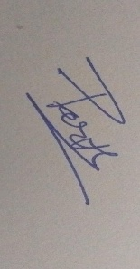
Signature of Student Signature of Faculty Member / Scholar
Name: Parth Pathak Name: Remya Sivan
Date: 30/9/2025 Date:

